SOP & LINK ZOOM PESERTA SIDANG FIKOMM
UNIVERSITAS MERCU BUANA YOGYAKARTA

LANGKAH MENGGUNAKAN LINK ZOOM FAKULTAS UMBY:
- Buka aplikasi zoom meeting di laptop yang disediakan laboratorium FIKOMM :
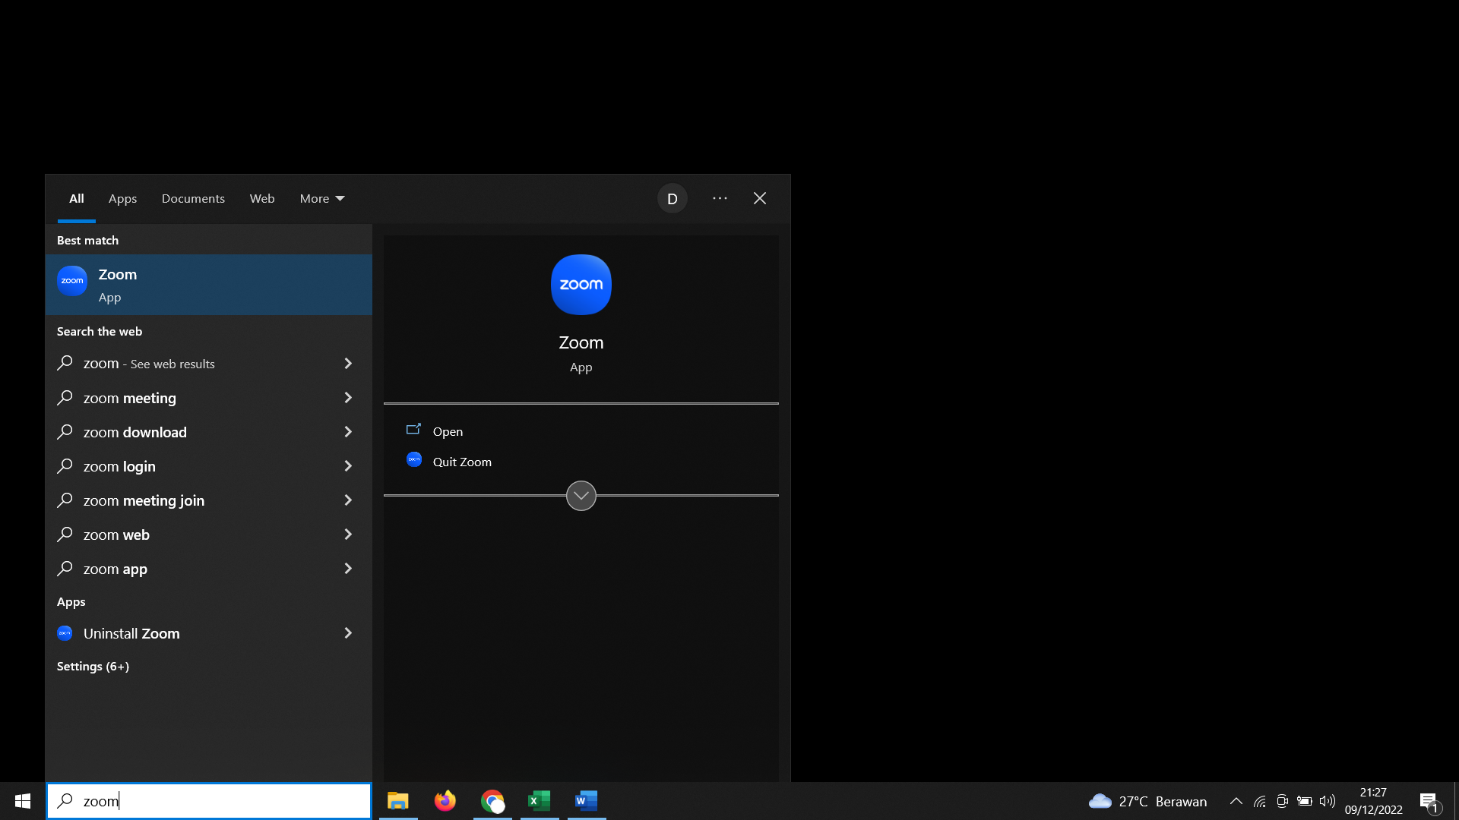
- Silahkan cari Nama anda dan Klik ”Start Meeting”
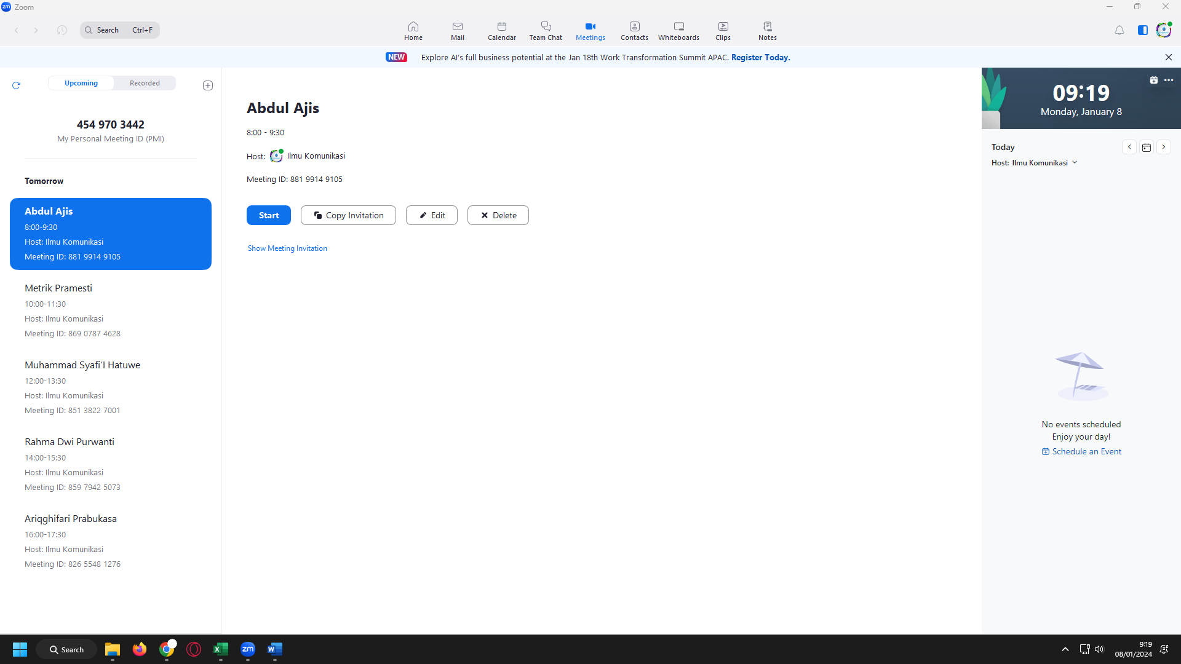

- Link Sidang untuk dikirimkan ke dosen pembimbing anda di bawah ini (link terlampir)
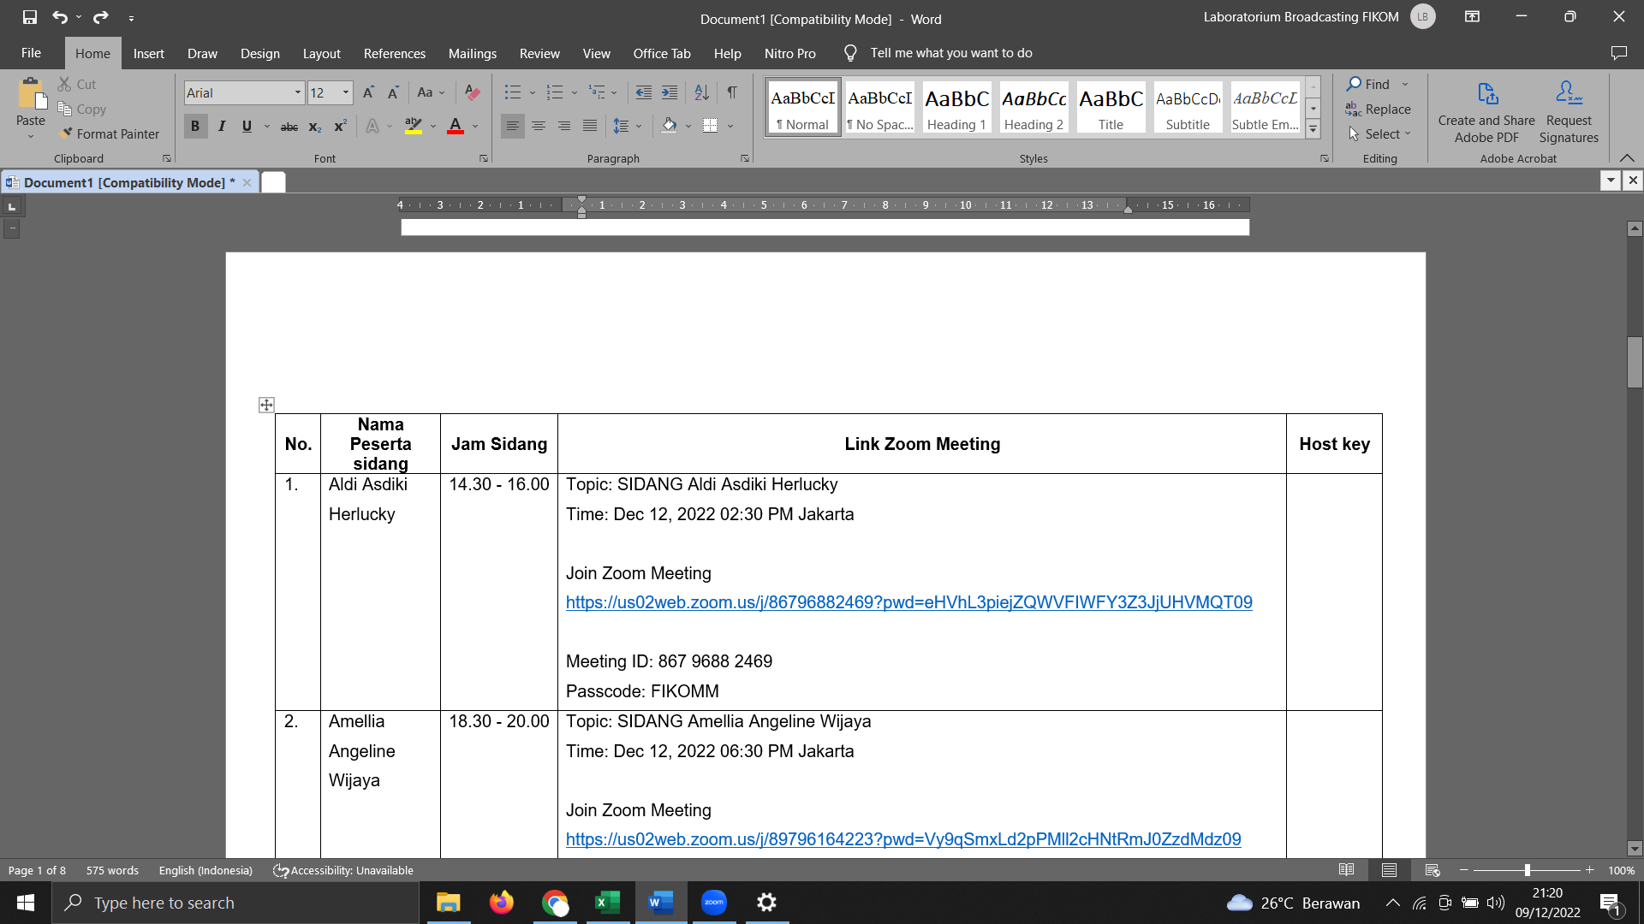

- Materi di upload di link :
https://drive.google.com/drive/folders/1q6L1y5oV6fh7vsMo9sciWts-Lqi8qzpx?usp=sharing

(akses bisa CTRL+Klik link di atas)

LINK ZOOM SIDANG PERIODE DESEMBER (Selasa, 9 Januari 2024)
No. | Nama Peserta sidang | Jam Sidang | Link Zoom Meeting | Host key
 | Abdul Ajis | 08.00 - 09.30 | Topic: Abdul Ajis  Time: Jan 9, 2024 08:00 Jakarta  Join Zoom Meeting  https://us02web.zoom.us/j/88199149105?pwd=OXYrTWdkbGJ4eEl1bTh0RS9JNFJyZz09  Meeting ID: 881 9914 9105  Passcode: FIKOMM | Host Key:  012023
 | Muhammad Rianto Rialdi | 08.00 - 09.30 | Topic: Muhammad Rianto Rialdi  Time: Jan 9, 2024 08:00 Jakarta  Join Zoom Meeting  https://us06web.zoom.us/j/81520658208?pwd=31sTWyA8Wo2oMUmNd5Hnae6Iyw99dy.1  Meeting ID: 815 2065 8208  Passcode: FIKOMM | Host Key:  012023
 | Metrik Pramesti | 10.00 - 11.30 | Topic: Metrik Pramesti  Time: Jan 9, 2024 10:00 Jakarta  Join Zoom Meeting  https://us02web.zoom.us/j/86907874628?pwd=VHBPZmtaUGd2eStucmdicndmRE1YUT09  Meeting ID: 869 0787 4628  Passcode: FIKOMM | Host Key:  012023
 | Amelia Oktaviani | 10.00 - 11.30 | Topic: Amelia Oktaviani  Time: Jan 9, 2024 10:00 Jakarta  Join Zoom Meeting  https://us06web.zoom.us/j/86933983790?pwd=VIbtnkaq88iUWxZwEvFDkbJULVh9vw.1  Meeting ID: 869 3398 3790  Passcode: FIKOMM | Host Key:  012023
 | Muhammad Syafi’I Hatuwe | 12:00 - 13.30 | Topic: Muhammad Syafi’I Hatuwe  Time: Jan 9, 2024 12:00 Jakarta  Join Zoom Meeting  https://us02web.zoom.us/j/85138227001?pwd=VW9QYTNOVjFuYmcrZDFmNEVvb0FXUT09  Meeting ID: 851 3822 7001  Passcode: FIKOMM | Host Key:  012023
 | Ahmad Sergi Wardhana | 12:00 - 13.30 | Topic: Ahmad Sergi Wardhana  Time: Jan 9, 2024 12:00 Jakarta  Join Zoom Meeting  https://us06web.zoom.us/j/81018410177?pwd=ZLCaEDVynYvG6NKS0aDC4Qr3xRbCs6.1  Meeting ID: 810 1841 0177  Passcode: FIKOMM | Host Key:  012023
 | Rahma Dwi Purwanti | 14:00 - 15.30 | Topic: Rahma Dwi Purwanti  Time: Jan 9, 2024 14:00 Jakarta  Join Zoom Meeting  https://us02web.zoom.us/j/85979425073?pwd=T2pLRmlRNFJhWDBGeWlCeFo1Vjhzdz09  Meeting ID: 859 7942 5073  Passcode: FIKOMM | Host Key:  012023
 | Arai Nisari | 14:00 - 15.30 | Topic: Arai Nisari  Time: Jan 9, 2024 14:00 Jakarta  Join Zoom Meeting  https://us06web.zoom.us/j/86981925228?pwd=tZVZGVc6evjMFJZhcfYfBbcpFqXy0M.1  Meeting ID: 869 8192 5228  Passcode: FIKOMM | Host Key:  012023
 | Ariqghifari Prabukasa | 16:00 - 17.30 | Topic: Ariqghifari Prabukasa  Time: Jan 9, 2024 16:00 Jakarta  Join Zoom Meeting  https://us02web.zoom.us/j/82655481276?pwd=cEJOd3hIenFtTGZkdFFhVE9MZ1VYZz09  Meeting ID: 826 5548 1276  Passcode: FIKOMM | Host Key:  012023
 | Mei Syella Br Pelawi | 16:00 - 17.30 | Topic: Mei Syella Br Pelawi  Time: Jan 9, 2024 16:00 Jakarta  Join Zoom Meeting  https://us06web.zoom.us/j/87850113342?pwd=K2ZzrSlppTH5DlkGapIf40SLUBbuQ0.1  Meeting ID: 878 5011 3342  Passcode: FIKOMM | Host Key:  012023

LINK ZOOM SIDANG PERIODE DESEMBER (Rabu, 10 Januari 2024)

No. | Nama Peserta sidang | Jam Sidang | Link Zoom Meeting | Host key
 | Feri Patria Fathurahman | 08.00 - 09.30 | Topic: Feri Patria Fathurahman  Time: Jan 10, 2024 08:00 Jakarta  Join Zoom Meeting  https://us02web.zoom.us/j/89946926912?pwd=STlNcVhWbzhTQWkzMlZkcFowZ3Yzdz09  Meeting ID: 899 4692 6912  Passcode: FIKOMM | Host Key:  012023
 | Hafizh Irfanariq Bahtiar | 10.00 - 11.30 | Topic: Hafizh Irfanariq Bahtiar  Time: Jan 10, 2024 10:00 Jakarta  Join Zoom Meeting  https://us02web.zoom.us/j/86524729960?pwd=MVR5OGFhZ2VrUHUyT1kybHhlaG9DZz09  Meeting ID: 865 2472 9960  Passcode: FIKOMM | Host Key:  012023
 | Endaresta Fega Destiara | 10.00 - 11.30 | Topic: Endaresta Fega Destiara  Time: Jan 10, 2024 10:00 Jakarta  Join Zoom Meeting  https://us06web.zoom.us/j/87134511309?pwd=atwYJFGFYogVmpPeLK7oqcQSTl1Ckg.1  Meeting ID: 871 3451 1309  Passcode: FIKOMM | Host Key:  012023
 | Try Ihsan Wicaksono | 12.00 - 13.30 | Topic: Try Ihsan Wicaksono  Time: Jan 10, 2024 12:00 Jakarta  Join Zoom Meeting  https://us02web.zoom.us/j/88039371352?pwd=M0JvNEVyOElOU2xMQmkrQzM4MU1yZz09  Meeting ID: 880 3937 1352  Passcode: FIKOMM | Host Key:  012023
 | Niken Trie Regina | 12.00 - 13.30 | Topic: Niken Trie Regina  Time: Jan 10, 2024 11:30 Jakarta  Join Zoom Meeting  https://us06web.zoom.us/j/82230712648?pwd=7A8d8lCGhaxaV2KHeElb6kmu0IRnbD.1  Meeting ID: 822 3071 2648  Passcode: FIKOMM | Host Key:  012023
 | Helda Hestiya | 14.00 - 15.30 | Topic: Helda Hestiya  Time: Jan 10, 2024 14:00 Jakarta  Join Zoom Meeting  https://us02web.zoom.us/j/82298986294?pwd=ZWxGdzVEQ1JndkFYa0VRKzFEbnFKdz09  Meeting ID: 822 9898 6294  Passcode: FIKOMM | Host Key:  012023
 | Ahmad Ridho Harsyid | 14.00 - 15.30 | Topic: Ahmad Ridho Harsyid  Time: Jan 10, 2024 14:00 Jakarta  Join Zoom Meeting  https://us06web.zoom.us/j/89796303160?pwd=i1kfKaATCN3T5wIYgGsM4fNdV3ZcWj.1  Meeting ID: 897 9630 3160  Passcode: FIKOMM | Host Key:  012023
 | Arkan Abdullah | 16.00 - 17.30 | Topic: Arkan Abdullah  Time: Jan 10, 2024 16:00 Jakarta  Join Zoom Meeting  https://us02web.zoom.us/j/89010507832?pwd=OE52Tzl5VGl5T2trOGNsZ3VZYWhVZz09  Meeting ID: 890 1050 7832  Passcode: FIKOMM | Host Key:  012023
 | Adam Anindra Rafzanjani | 16.00 - 17.30 | Topic: Adam Anindra Rafzanjani  Time: Jan 10, 2024 16:00 Jakarta  Join Zoom Meeting  https://us06web.zoom.us/j/84992547628?pwd=7NKAauzlueabSqaqMXNxruQd4Pb0ys.1  Meeting ID: 849 9254 7628  Passcode: FIKOMM | Host Key:  012023
 | Vina Miftahurrohmah | 18.00-19.30 | Topic: Vina Miftahurrohmah  Time: Jan 10, 2024 17:00 Jakarta  Join Zoom Meeting  https://us02web.zoom.us/j/81659964896?pwd=UUFRMGs3bGZWR0c5UzdDYlJPYmRtUT09  Meeting ID: 816 5996 4896  Passcode: FIKOMM | Host Key:  012023
LINK ZOOM SIDANG PERIODE DESEMBER (Kamis, 11 Januari 2024)
No. | Nama Peserta sidang | Jam Sidang | Link Zoom Meeting | Host key
 | Audry Nauval | 08.00 - 09.30 | Topic: Audry Nauval  Time: Jan 11, 2024 10:30 Jakarta  Join Zoom Meeting  https://us02web.zoom.us/j/85145331449?pwd=b0RKd202bTI1NW5mMG9sVWRlTVAvZz09  Meeting ID: 851 4533 1449  Passcode: FIKOMM | Host Key:  012023
 | Sinta Kristanti Puspita | 08.00 - 09.30 | Topic: Sinta Kristanti Puspita  Time: Jan 11, 2024 08:00 Jakarta  Join Zoom Meeting  https://us06web.zoom.us/j/88260479085?pwd=zamAJ0J5gZksFzbkVDhb2HViZO4yZF.1  Meeting ID: 882 6047 9085  Passcode: FIKOMM | Host Key:  012023
 | Caswati | 10.00 - 11.30 | Topic: Caswati  Time: Jan 11, 2024 10:00 Jakarta  Join Zoom Meeting  https://us02web.zoom.us/j/85279557464?pwd=cGNhaHdoeDVIazAwNzlDWXN3R200QT09  Meeting ID: 852 7955 7464  Passcode: FIKOMM | Host Key:  012023
 | Faradilla Az Zahra | 10.00 - 11.30 | Topic: Faradilla Az Zahra  Time: Jan 11, 2024 10:00 Jakarta  Join Zoom Meeting  https://us06web.zoom.us/j/86903829150?pwd=QYwa6XBbL6CY1fEIQ7YsE3blohO9jh.1  Meeting ID: 869 0382 9150  Passcode: FIKOMM | Host Key:  012023
 | Dinda Maharani Siswanto | 12.00 - 13.30 | Topic: Dinda Maharani Siswanto  Time: Jan 11, 2024 12:00 Jakarta  Join Zoom Meeting  https://us02web.zoom.us/j/84818248970?pwd=Y0dFcmxyR2RMRGhERVp0STBzcTFSQT09  Meeting ID: 848 1824 8970  Passcode: FIKOMM | Host Key:  012023
 | Barnabas Rio Yeheskiel Nababan | 12.00 - 13.30 | Topic: Barnabas Rio Yeheskiel Nababan  Time: Jan 11, 2024 12:00 Jakarta  Join Zoom Meeting  https://us06web.zoom.us/j/81892357486?pwd=hI0CMr7QNarYoHbXoHFbbCHvFva89Y.1  Meeting ID: 818 9235 7486  Passcode: FIKOMM | Host Key:  012023
 | Asri Kusumahati | 14.00 - 15.30 | Topic: Asri Kusumahati  Time: Jan 11, 2024 14:00 Jakarta  Join Zoom Meeting  https://us02web.zoom.us/j/87544737242?pwd=U0tNaXFBa2N1azQ4WnBwN2J2eG5Tdz09  Meeting ID: 875 4473 7242  Passcode: FIKOMM | Host Key:  012023
 | Muhammad Daffa Daehan Persada | 14.00 - 15.30 | Topic: Muhammad Daffa Daehan Persada  Time: Jan 11, 2024 14:00 Jakarta  Join Zoom Meeting  https://us06web.zoom.us/j/87455565992?pwd=wsvobWMnT1GWwKdHbLpM96uV5bBTCF.1  Meeting ID: 874 5556 5992  Passcode: FIKOMM | Host Key:  012023
 | I Gede Ardika | 16.00 - 17.30 | Topic: I Gede Ardika  Time: Jan 11, 2024 16:00 Jakarta  Join Zoom Meeting  https://us02web.zoom.us/j/88129106880?pwd=MXZmNm94TDVjd3RldFpONHRqNlg5Zz09  Meeting ID: 881 2910 6880  Passcode: FIKOMM | Host Key:  012023
 | Nur Sheyhaq | 16.00 - 17.30 | Topic: Nur Sheyhaq  Time: Jan 11, 2024 16:00 Jakarta  Join Zoom Meeting  https://us06web.zoom.us/j/89078284319?pwd=cqeVcQHl6GdO2Ux16qKYDRHYVNzl8Y.1  Meeting ID: 890 7828 4319  Passcode: FIKOMM | Host Key:  012023
 | Iqzan Pratayuda | 18.30 - 20.00 | Topic: Iqzan Pratayuda  Time: Jan 11, 2024 18:30 Jakarta  Join Zoom Meeting  https://us02web.zoom.us/j/81704121167?pwd=SzF0WlBRbHllbjR3QmpPZlFoTU5OQT09  Meeting ID: 817 0412 1167  Passcode: FIKOMM | Host Key:  012023
 | Musafa | 18.30 - 20.00 | Topic: Musafa  Time: Jan 11, 2024 18:30 Jakarta  Join Zoom Meeting  https://us06web.zoom.us/j/82529096844?pwd=JVobMFhU87ny09Jauqbhcz8uFeHBwJ.1  Meeting ID: 825 2909 6844  Passcode: FIKOMM | Host Key:  012023

LINK ZOOM SIDANG PERIODE DESEMBER (Jumat, 12 Januari 2024)
No. | Nama Peserta sidang | Jam Sidang | Link Zoom Meeting | Host key
 | Oviy Oktaliesa | 08.00 - 09.30 | Topic: Oviy Oktaliesa  Time: Jan 12, 2024 08:00 Jakarta  Join Zoom Meeting  https://us02web.zoom.us/j/87564393994?pwd=Wi9JczExa2ZtVlJvK0RnZjZESG9UQT09  Meeting ID: 875 6439 3994  Passcode: FIKOMM | Host Key:  012023
 | Dini Nurhayati | 10.00 - 11.30 | Topic: Dini Nurhayati  Time: Jan 12, 2024 10:00 Jakarta  Join Zoom Meeting  https://us02web.zoom.us/j/86726499279?pwd=THJTWUFndUp4SUZ5L0NXSUNySVQxQT09  Meeting ID: 867 2649 9279  Passcode: FIKOMM | Host Key:  012023
 | Windarti Yuliana | 13.00 - 14.30 | Topic: Windarti Yuliana  Time: Jan 12, 2024 13:00 Jakarta  Join Zoom Meeting  https://us02web.zoom.us/j/86154394128?pwd=M3RkMTg3TVFLem90bUFDc0NtbVpjUT09  Meeting ID: 861 5439 4128  Passcode: FIKOMM | Host Key:  012023
 | Rita Novitasari | 13.00 - 14.30 | Topic: Rita Novitasari  Time: Jan 12, 2024 13:00 Jakarta  Join Zoom Meeting  https://us06web.zoom.us/j/87318970356?pwd=TC7y1ukqBjRjgKSY5UUtnB8mk7QtSN.1  Meeting ID: 873 1897 0356  Passcode: FIKOMM | Host Key:  012023
 | Nuzulian Abdul Majid | 15.00 - 16.30 | Topic: Nuzulian Abdul Majid  Time: Jan 12, 2024 15:00 Jakarta  Join Zoom Meeting  https://us02web.zoom.us/j/82049450300?pwd=TVRxc1BuMkkvNFc5SEZJUzMxekpZUT09  Meeting ID: 820 4945 0300  Passcode: FIKOMM | Host Key:  012023
 | Muhammad Rifki | 15.00 - 16.30 | Topic: Muhammad Rifki  Time: Jan 12, 2024 15:00 Jakarta  Join Zoom Meeting  https://us06web.zoom.us/j/81387111357?pwd=SCDbZB2Cu1h47QcVAgUfBGQWIuEOEf.1  Meeting ID: 813 8711 1357  Passcode: FIKOMM | Host Key:  012023
 | Egidia Angelica br Pelawi | 17.00 - 18.30 | Topic: Egidia Angelica br Pelawi  Time: Jan 12, 2024 17:00 Jakarta  Join Zoom Meeting  https://us02web.zoom.us/j/88527861284?pwd=aFM1TUk2b2dPZXlETDJGTDM3bmg5QT09  Meeting ID: 885 2786 1284  Passcode: FIKOMM | Host Key:  012023
 | Dwi Asara Watin | 17.00 - 18.30 | Topic: Dwi Asara Watin  Time: Jan 12, 2024 17:00 Jakarta  Join Zoom Meeting  https://us06web.zoom.us/j/88904028973?pwd=jzqySsHo9zKMwykeJrTKj2mxL9JCU0.1  Meeting ID: 889 0402 8973  Passcode: FIKOMM | Host Key:  012023

