**SOP & LINK ZOOM PESERTA SIDANG FIKOMM**

**UNIVERSITAS MERCU BUANA YOGYAKARTA**

**LANGKAH MENGGUNAKAN LINK ZOOM FAKULTAS UMBY:**

1. **Buka aplikasi zoom** meeting di **laptop yang disediakan** laboratorium FIKOMM :

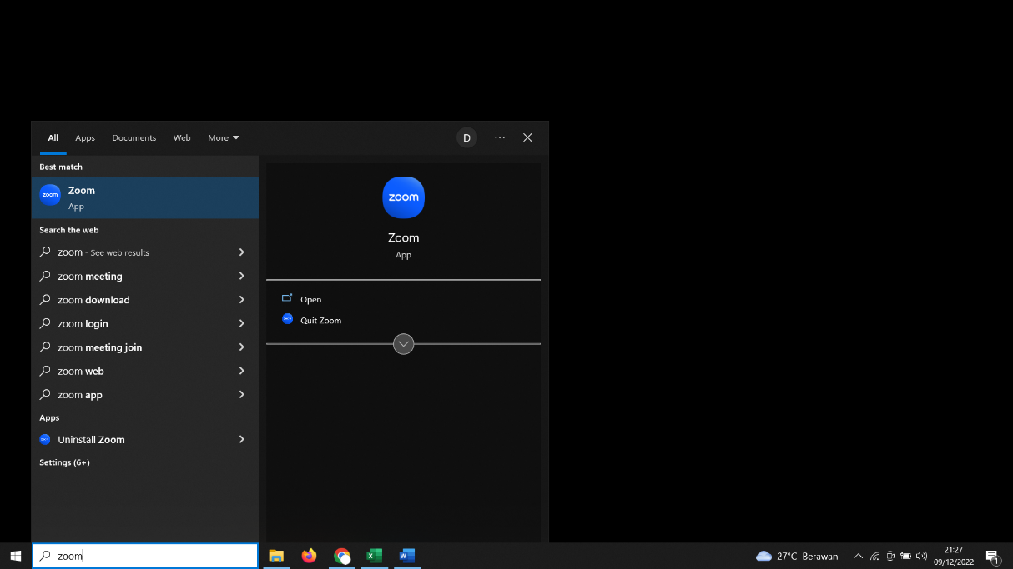

1. **Silahkan cari Nama anda dan Klik ”Start Meeting”**

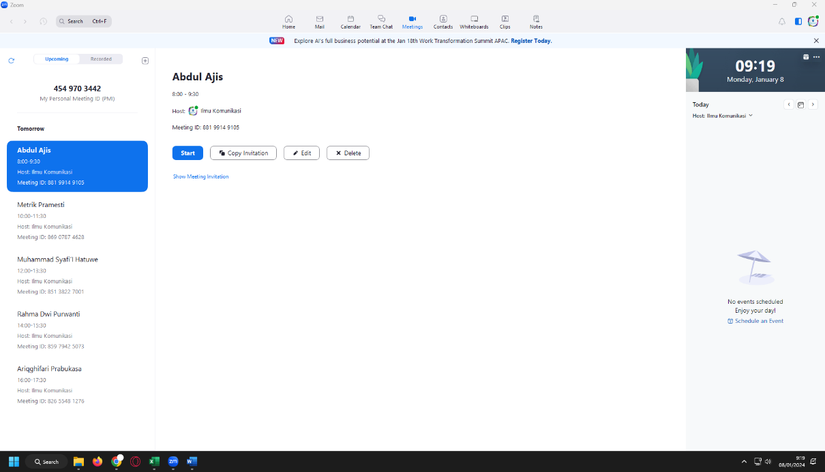

1. **Link Sidang untuk dikirimkan ke dosen pembimbing** anda di bawah ini **(*link* *terlampir*)**

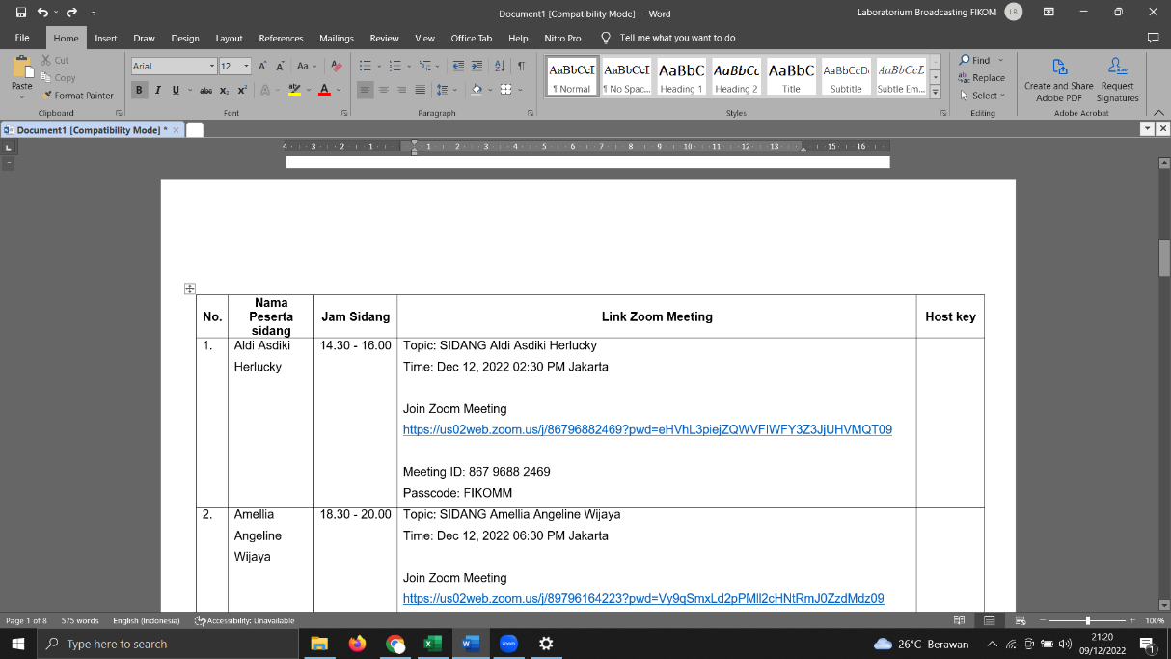

1. Materi di upload di link :

<https://drive.google.com/drive/folders/1q6L1y5oV6fh7vsMo9sciWts-Lqi8qzpx?usp=sharing>

(akses bisa **CTRL+Klik link di atas**)

**LINK ZOOM SIDANG PERIODE DESEMBER ( Kamis, 12 Desember 2024)**

|  |  |  |  |  |
| --- | --- | --- | --- | --- |
| **No.** | **Nama Peserta Sidang** | **Jam Sidang** | **Link Zoom Meeting** | **Host Key** |
|  | Thomas Ronaldo | 08.00-09.30 WIB | Topik: Thomas Ronaldo  Waktu: 12 Des 2024 08:00 Jakarta  Bergabung Zoom Rapat  <https://us02web.zoom.us/j/89554410704?pwd=ZxHADtu1Trbfp8lYE5PzfcWSP9jw4q.1>  ID Rapat: 895 5441 0704  Kode Sandi: FIKOMM | Host Key:  **012023** |
|  | Ica Ervina | 08.00-09.30 WIB | Topic: Ica Ervina  Waktu: 12 Des 2024 08:00 Jakarta  Join Zoom Meeting  <https://us06web.zoom.us/j/89678081720?pwd=SdN2ah144GvWzfqy2PkPr5fyfC1eEo.1>  Meeting ID: 896 7808 1720  Passcode: FIKOMM | Host Key: **111888** |
|  | Ngudi Wahyu | 10.00-11.30 WIB | Topik: Ngudi Wahyu  Waktu: 12 Des 2024 10:00 Jakarta  Bergabung Zoom Rapat  <https://us02web.zoom.us/j/81994710907?pwd=u9Ip8qDKzehYqaPB7AAbfsUEEhIbHl.1>  ID Rapat: 819 9471 0907  Kode Sandi: FIKOMM | Host Key:  **012023** |
|  | Chandra Satya Bintara | 10.00-11.30 WIB | Topic: Chandra Satya Bintara  Waktu: 12 Des 2024 10:00 Jakarta  Join Zoom Meeting  <https://us06web.zoom.us/j/89678081720?pwd=SdN2ah144GvWzfqy2PkPr5fyfC1eEo.1>  Meeting ID: 896 7808 1720  Passcode: FIKOMM | Host Key: **111888** |
|  | Ladusya Parama Wicaksono | 13.00-14.30 WIB | Topik: Ladusya Parama Wicaksono  Waktu: 12 Des 2024 13:00 Jakarta  Bergabung Zoom Rapat  <https://us02web.zoom.us/j/82975438409?pwd=HCbBK4VkHN9N8eMLXnpcB4ePLDUVoE.1>  ID Rapat: 829 7543 8409  Kode Sandi: FIKOMM | Host Key:  **012023** |
|  | Erlika Yusfiarista | 13.00-14.30 WIB | Topic: Erlika Yusfiarista  Waktu: 12 Des 2024 13:00 Jakarta  Join Zoom Meeting  <https://us06web.zoom.us/j/89678081720?pwd=SdN2ah144GvWzfqy2PkPr5fyfC1eEo.1>  Meeting ID: 896 7808 1720  Passcode: FIKOMM | Host Key: **111888** |
|  | Atika Sari | 15.00-16.30 WIB | Topik: Atika Sari  Waktu: 12 Des 2024 15:00 Jakarta  Bergabung Zoom Rapat  <https://us02web.zoom.us/j/81662721017?pwd=6yysIbFbP0MKExQAbk0YvKJcnUPpL9.1>  ID Rapat: 816 6272 1017  Kode Sandi: FIKOMM | Host Key:  **012023** |

**LINK ZOOM SIDANG PERIODE DESEMBER ( Jumat, 13 Desember 2024)**

|  |  |  |  |  |
| --- | --- | --- | --- | --- |
| **No.** | **Nama Peserta Sidang** | **Jam Sidang** | **Link Zoom Meeting** | **Host Key** |
|  | Naufal Ariq Fadhel | 08.00-09.30 WIB | Topik: Naufal Ariq Fadhel  Waktu: 13 Des 2024 08:00 Jakarta  Bergabung Zoom Rapat  <https://us02web.zoom.us/j/86219874160?pwd=bB07bEN4WvV5xfZv9AffTlOe5gSAXo.1>  ID Rapat: 862 1987 4160  Kode Sandi: FIKOMM | Host Key:  **012023** |
|  | Melkrisman Saamad | 08.00-09.30 WIB | Topic: Melkrisman Saamad  Waktu: 13 Des 2024 08:00 Jakarta  Join Zoom Meeting  <https://us06web.zoom.us/j/83452029710?pwd=vGaQZ9DDWcfewhlgbtuIaSbPOPtARI.1>  Meeting ID: 834 5202 9710  Passcode: FIKOMM | Host Key: **111888** |
|  | Mutiara | 10.00-11.30 WIB | Topik: Mutiara  Waktu: 13 Des 2024 10:00 Jakarta  Bergabung Zoom Rapat  <https://us02web.zoom.us/j/83547803547?pwd=lHeCFx8O6Ea4yxH4J7uVdI6ZbNzshO.1>  ID Rapat: 835 4780 3547  Kode Sandi: FIKOMM | Host Key:  **012023** |
|  | Jeari Hardi Sitepu | 10.00-11.30 WIB | Topic: Jeari Hardi Sitepu  Waktu: 13 Des 2024 10:00 Jakarta  Join Zoom Meeting  <https://us06web.zoom.us/j/83452029710?pwd=vGaQZ9DDWcfewhlgbtuIaSbPOPtARI.1>  Meeting ID: 834 5202 9710  Passcode: FIKOMM | Host Key: **111888** |
|  | Nisa Natalia Haloho | 13.00-14.30 WIB | Topik: Nisa Natalia Haloho  Waktu: 13 Des 2024 13:00 Jakarta  Bergabung Zoom Rapat  <https://us02web.zoom.us/j/85283858195?pwd=1QwoVfz240UmRUr5PetE8VPeKhmmmQ.1>  ID Rapat: 852 8385 8195  Kode Sandi: FIKOMM | Host Key:  **012023** |

**LINK ZOOM SIDANG PERIODE DESEMBER ( Senin, 16 Desember 2024)**

|  |  |  |  |  |
| --- | --- | --- | --- | --- |
| **No.** | **Nama Peserta Sidang** | **Jam Sidang** | **Link Zoom Meeting** | **Host Key** |
|  | Remo Andiko | 08.00-09.30 WIB | Topik: Remo Andiko  Waktu: 16 Des 2024 08:00 Jakarta  Bergabung Zoom Rapat  <https://us02web.zoom.us/j/81678337544?pwd=Gcaw847bwL6EvovOvBpr5a9a0kNSvA.1>  ID Rapat: 816 7833 7544  Kode Sandi: FIKOMM | Host Key:  **012023** |
|  | Kelvin Firmansyah | 08.00-09.30 WIB | Topic: Kelvin Firmansyah  Waktu: 16 Des 2024 08:00 Jakarta  Join Zoom Meeting  <https://us06web.zoom.us/j/81435268923?pwd=BncChVOrdmfPProYyk1YHUmaHWjmai.1>  Meeting ID: 814 3526 8923  Passcode: FIKOMM | Host Key: **111888** |
|  | Samuel Fetanin Djetul | 10.00-11.30 WIB | Topik: Samuel Fetanin Djetul  Waktu: 16 Des 2024 10:00 Jakarta  Bergabung Zoom Rapat  <https://us02web.zoom.us/j/85856901716?pwd=bIMiyAb4sMUS83R2K4vbCVs0QQUFbR.1>  ID Rapat: 858 5690 1716  Kode Sandi: FIKOMM | Host Key:  **012023** |
|  | Bintang Ilham Pratama | 10.00-11.30 WIB | Topic: Bintang Ilham Pratama  Waktu: 16 Des 2024 10:00 Jakarta  Join Zoom Meeting  <https://us06web.zoom.us/j/81435268923?pwd=BncChVOrdmfPProYyk1YHUmaHWjmai.1>  Meeting ID: 814 3526 8923  Passcode: FIKOMM | Host Key: **111888** |
|  | Riski Pajar Putra | 13.00-14.30 WIB | Topik: Riski Pajar Putra  Waktu: 16 Des 2024 13:00 Jakarta  Bergabung Zoom Rapat  <https://us02web.zoom.us/j/86827906686?pwd=DrfXGnb7D44KKkniILITbcJ3kZSiKD.1>  ID Rapat: 868 2790 6686  Kode Sandi: FIKOMM | Host Key:  **012023** |
|  | Muhammad Arifki Nurcahyono | 13.00-14.30 WIB | Topic: Muhammad Arifki Nurcahyono  Waktu: 16 Des 2024 13:00 Jakarta  Join Zoom Meeting  <https://us06web.zoom.us/j/81435268923?pwd=BncChVOrdmfPProYyk1YHUmaHWjmai.1>  Meeting ID: 814 3526 8923  Passcode: FIKOMM | Host Key: **111888** |
|  | Syifa Fauziyah El Samie | 15.00 - 16.30 WIB | Topik: Syifa Fauziyah El Samie  Waktu: 16 Des 2024 15:00 Jakarta  Bergabung Zoom Rapat  <https://us02web.zoom.us/j/87521199478?pwd=6wSgXeVZbZicEywELbGgr3mH6yxDSy.1>  ID Rapat: 875 2119 9478  Kode Sandi: FIKOMM | Host Key:  **012023** |
|  | Tania Sunilah Hartono | 15.00 - 16.30 WIB | Topic: Tania Sunilah Hartono  Waktu: 16 Des 2024 15:00 Jakarta  Join Zoom Meeting  <https://us06web.zoom.us/j/81435268923?pwd=BncChVOrdmfPProYyk1YHUmaHWjmai.1>  Meeting ID: 814 3526 8923  Passcode: FIKOMM | Host Key: **111888** |
|  | Adnan Kasogi | 17.00 - 18.30 WIB | Topik: Adnan Kasogi  Waktu: 16 Des 2024 17:00 Jakarta  Bergabung Zoom Rapat  <https://us02web.zoom.us/j/81467588643?pwd=ohu9a7hGPm4P0JIdnhCqvTywyBzsfa.1>  ID Rapat: 814 6758 8643  Kode Sandi: FIKOMM | Host Key:  **012023** |
|  | Dhalif Wahyu Prasetya | 17.00 - 18.30 WIB | Topic: Dhalif Wahyu Prasetya  Waktu: 16 Des 2024 17:00 Jakarta  Join Zoom Meeting  <https://us06web.zoom.us/j/81435268923?pwd=BncChVOrdmfPProYyk1YHUmaHWjmai.1>  Meeting ID: 814 3526 8923  Passcode: FIKOMM | Host Key: **111888** |

**LINK ZOOM SIDANG PERIODE DESEMBER ( Selasa, 17 Desember 2024)**

|  |  |  |  |  |
| --- | --- | --- | --- | --- |
| **No.** | **Nama Peserta Sidang** | **Jam Sidang** | **Link Zoom Meeting** | **Host Key** |
|  | Claresta Priskila | 08.00-09.30 WIB | Topik: Claresta Priskila  Waktu: 17 Des 2024 08:00 Jakarta  Bergabung Zoom Rapat  <https://us02web.zoom.us/j/83040715704?pwd=gVTp3WwoJ3LRR3rk8nGg4cvPbWD294.1>  ID Rapat: 830 4071 5704  Kode Sandi: FIKOMM | Host Key:  **012023** |
|  | Indah Rizkiyana | 08.00-09.30 WIB | Topic: Indah Rizkiyana  Waktu: 17 Des 2024 08:00 Jakarta  Join Zoom Meeting  <https://us06web.zoom.us/j/81206371749?pwd=0fLY2zDkl5RM7HdOp9E3i1L976nHWe.1>  Meeting ID: 812 0637 1749  Passcode: FIKOMM | Host Key: **111888** |
|  | Cut Rayhanun Hafizah Rahman | 10.00-11.30 WIB | Topik: Cut Rayhanun Hafizah Rahman  Waktu: 17 Des 2024 10:00 Jakarta  Bergabung Zoom Rapat  <https://us02web.zoom.us/j/81517105276?pwd=6p52bo4BHF1dOBbcQullVD8V6QTM1e.1>  ID Rapat: 815 1710 5276  Kode Sandi: FIKOMM | Host Key:  **012023** |
|  | Alifia Indah Floresty | 10.00-11.30 WIB | Topic: Alifia Indah Floresty  Waktu: 17 Des 2024 10:00 Jakarta  Join Zoom Meeting  <https://us06web.zoom.us/j/81206371749?pwd=0fLY2zDkl5RM7HdOp9E3i1L976nHWe.1>  Meeting ID: 812 0637 1749  Passcode: FIKOMM | Host Key: **111888** |
|  | Nelvina Abel Mulyadi | 13.00-14.30 WIB | Topik: Nelvina Abel Mulyadi  Waktu: 17 Des 2024 13:00 Jakarta  Bergabung Zoom Rapat  <https://us02web.zoom.us/j/86967927260?pwd=FtmsP8uDBJf019tj8JWadla54kIlf8.1>  ID Rapat: 869 6792 7260  Kode Sandi: FIKOMM | Host Key:  **012023** |
|  | Hafidoh Azahra | 13.00-14.30 WIB | Topic: Hafidoh Azahra  Waktu: 17 Des 2024 13:00 Jakarta  Join Zoom Meeting  <https://us06web.zoom.us/j/81206371749?pwd=0fLY2zDkl5RM7HdOp9E3i1L976nHWe.1>  Meeting ID: 812 0637 1749  Passcode: FIKOMM | Host Key: **111888** |
|  | Viyas Bandriyo | 15.00-16.30 WIB | Topik: Viyas Bandriyo  Waktu: 17 Des 2024 15:00 Jakarta  Bergabung Zoom Rapat  <https://us02web.zoom.us/j/84752282206?pwd=brADrEqZhtO79zbSYWoDWCEUNjgg48.1>  ID Rapat: 847 5228 2206  Kode Sandi: FIKOMM | Host Key:  **012023** |
|  | Diva Ayu Subagja | 15.00-16.30 WIB | Topic: Diva Ayu Subagja  Waktu: 17 Des 2024 15:00 Jakarta  Join Zoom Meeting  <https://us06web.zoom.us/j/81206371749?pwd=0fLY2zDkl5RM7HdOp9E3i1L976nHWe.1>  Meeting ID: 812 0637 1749  Passcode: FIKOMM | Host Key: **111888** |
|  | Muhammad Farhan Abyan | 17.00-18.30 WIB | Topik: Muhammad Farhan Abyan  Waktu: 17 Des 2024 17:00 Jakarta  Bergabung Zoom Rapat  <https://us02web.zoom.us/j/82097330874?pwd=xUthhugzyc3gVylTEG7ZEvWOaqTtd3.1>  ID Rapat: 820 9733 0874  Kode Sandi: FIKOMM | Host Key:  **012023** |
|  | Beby Ayu Larasati | 17.00-18.30 WIB | Topic: Beby Ayu Larasati  Waktu: 17 Des 2024 17:00 Jakarta  Join Zoom Meeting  <https://us06web.zoom.us/j/81206371749?pwd=0fLY2zDkl5RM7HdOp9E3i1L976nHWe.1>  Meeting ID: 812 0637 1749  Passcode: FIKOMM | Host Key: **111888** |

**LINK ZOOM SIDANG PERIODE DESEMBER ( Rabu, 18 Desember 2024)**

|  |  |  |  |  |
| --- | --- | --- | --- | --- |
| **No.** | **Nama Peserta Sidang** | **Jam Sidang** | **Link Zoom Meeting** | **Host Key** |
|  | Ayu Widhiyanti Prasetyo | 08.00-09.30 WIB | Topik: Ayu Widhiyanti Prasetyo  Waktu: 18 Des 2024 08:00 Jakarta  Bergabung Zoom Rapat  <https://us02web.zoom.us/j/84857061178?pwd=hF3awuu4fZ2dwNDaMPz6aSC5NeoLzU.1>  ID Rapat: 848 5706 1178  Kode Sandi: FIKOMM | Host Key:  **012023** |
|  | Fikram Hurulean | 08.00-09.30 WIB | Topic: Fikram Hurulean  Waktu: 18 Des 2024 08:00 Jakarta  Join Zoom Meeting  <https://us06web.zoom.us/j/82899261759?pwd=8nsixhWpM2Zbfk80DTRvTKdDNJ4ts0.1>  Meeting ID: 828 9926 1759  Passcode: FIKOMM | Host Key: **111888** |
|  | Moch Maghfirah Adnan B | 10.00-11.30 WIB | Topik: Moch Maghfirah Adnan B  Waktu: 18 Des 2024 10:00 Jakarta  Bergabung Zoom Rapat  <https://us02web.zoom.us/j/85206662906?pwd=NrFUu0uO8w0l7m4YBAy9Kx6VO7VDno.1>  ID Rapat: 852 0666 2906  Kode Sandi: FIKOMM | Host Key:  **012023** |
|  | Izzah Putra Lasabri | 13.00-14.30 WIB | Topik: Izzah Putra Lasabri  Waktu: 18 Des 2024 13:00 Jakarta  Bergabung Zoom Rapat  <https://us02web.zoom.us/j/82221640711?pwd=C0NVPbRVXZWZ7bMlhXSaA585287ZHJ.1>  ID Rapat: 822 2164 0711  Kode Sandi: FIKOMM | Host Key:  **012023** |
|  | Aryos Dyega Wijaya | 15.00-16.30 WIB | Topik: Aryos Dyega Wijaya  Waktu: 18 Des 2024 15:00 Jakarta  Bergabung Zoom Rapat  <https://us02web.zoom.us/j/86597048255?pwd=cikbATw3fWZoVXtQRGxC08m5qLaqnX.1>  ID Rapat: 865 9704 8255  Kode Sandi: FIKOMM | Host Key:  **012023** |
|  | Tika Lestiana | 17.00-18.30 WIB | Topik: Tika Lestiana  Waktu: 18 Des 2024 17:00 Jakarta  Bergabung Zoom Rapat  <https://us02web.zoom.us/j/89659568070?pwd=dD3u5ZeZ1I0bPsxqOAa3Mqm18OUilq.1>  ID Rapat: 896 5956 8070  Kode Sandi: FIKOMM | Host Key:  **012023** |

**LINK ZOOM SIDANG PERIODE DESEMBER ( Kamis, 19 Desember 2024)**

|  |  |  |  |  |
| --- | --- | --- | --- | --- |
| **No.** | **Nama Peserta Sidang** | **Jam Sidang** | **Link Zoom Meeting** | **Host Key** |
|  | Rizki Julistiyani | 08.00-09.30 WIB | Topik: Rizki Julistiyani  Waktu: 19 Des 2024 08:00 Jakarta  Bergabung Zoom Rapat  <https://us02web.zoom.us/j/87358317273?pwd=1MaQaZsxrAUUp7kCyDXYgt3abbjwcA.1>  ID Rapat: 873 5831 7273  Kode Sandi: FIKOMM | Host Key:  **012023** |
|  | Sri Pangestu | 10.00 - 11.30 WIB | Topik: Sri Pangestu  Waktu: 19 Des 2024 10:00 Jakarta  Bergabung Zoom Rapat  <https://us02web.zoom.us/j/87261029121?pwd=deJbUot7LzXxvYbI8E650x7qFaMAcE.1>  ID Rapat: 872 6102 9121  Kode Sandi: FIKOMM | Host Key:  **012023** |