**SOP & LINK ZOOM PESERTA SIDANG FIKOMM**

**UNIVERSITAS MERCU BUANA YOGYAKARTA**

**LANGKAH MENGGUNAKAN LINK ZOOM FAKULTAS UMBY:**

1. **Buka aplikasi zoom** meeting di **laptop yang disediakan** laboratorium FIKOMM :

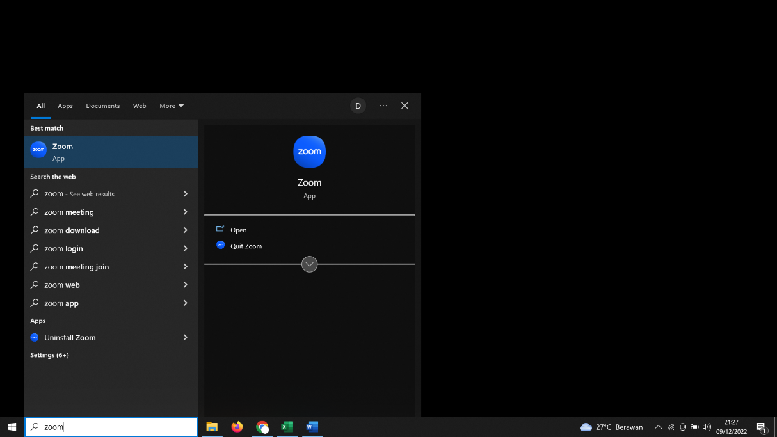

1. **Silahkan cari Nama anda dan Klik ”Start Meeting”**

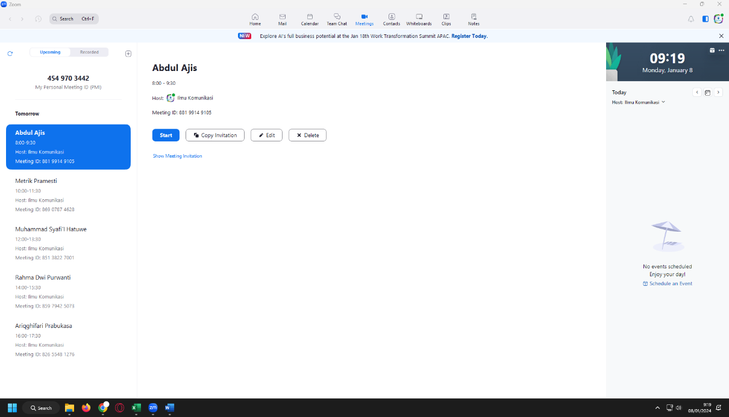

1. **Link Sidang untuk dikirimkan ke dosen pembimbing** anda di bawah ini **(*link* *terlampir*)**

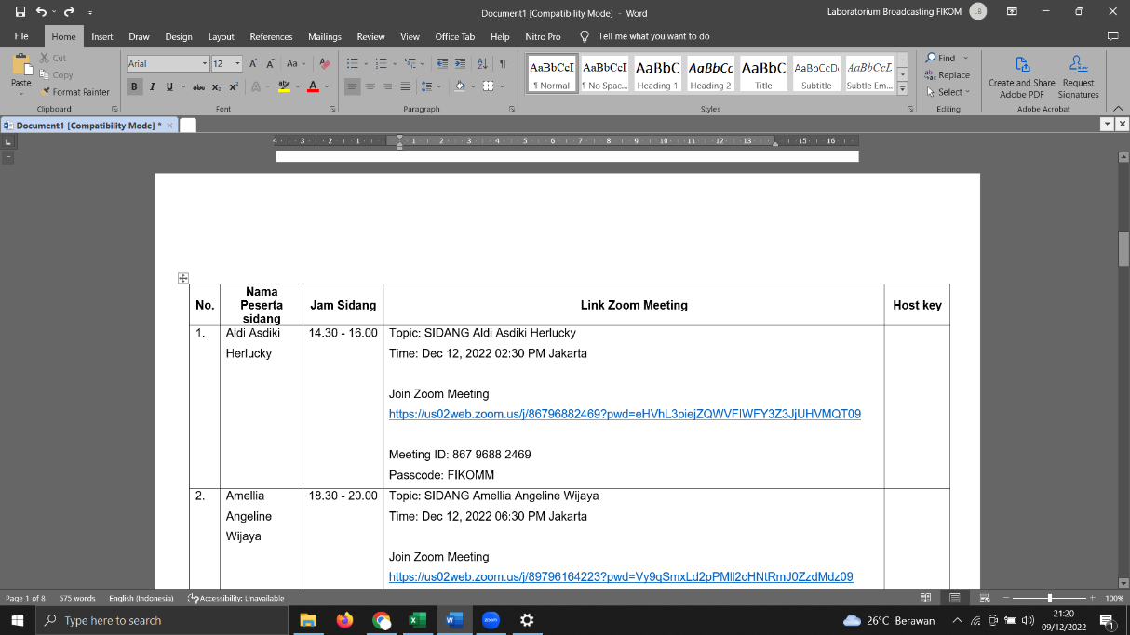

1. Materi di upload di link :

<https://drive.google.com/drive/folders/10RTBJzDaIjOpFzylhb4RMWeEWv_c-XLD?usp=sharing>

(akses bisa **CTRL+Klik link di atas**)

**LINK ZOOM SIDANG PERIODE JANUARI ( Senin, 13 Januari 2025)**

|  |  |  |  |  |
| --- | --- | --- | --- | --- |
| **No.** | **Nama Peserta Sidang** | **Jam Sidang** | **Link Zoom Meeting** | **Host Key** |
|  | Kamaluddin Ramdani | 08.00 – 09.30 WIB | Topic: Kamaluddin Ramdani  Time: Jan 13, 2025 08:00 Jakarta  Join Zoom Meeting  <https://us02web.zoom.us/j/89620161391?pwd=FWeYsFn2ezbRnFnJiLBwujbJEw3KBL.1>  Meeting ID: 896 2016 1391  Passcode: FIKOMM | Host Key:  **012023** |
|  | Deon Vito Karta Wijaya | 08.00 - 09.30 WIB | Topic: Deon Vito Karta Wijaya  Time: Jan 13, 2025 08.00 Jakarta  Join Zoom Meeting  <https://us06web.zoom.us/j/83274807085?pwd=MZLv4hZGq6D33cw9xiQMtbOJ7IbOQk.1>  Meeting ID: 832 7480 7085  Passcode: FIKOMM | Host Key:  **111888** |
|  | Mia Maida Putri | 10.00 - 11.30 WIB | Topic: Mia Maida Putri  Time: Jan 13, 2025 10:00 Jakarta  Join Zoom Meeting  <https://us02web.zoom.us/j/84470841383?pwd=qZaHGlbnTyPbcSiE3b8c8z7Wmxc0Lk.1>  Meeting ID: 844 7084 1383  Passcode: FIKOMM | Host Key:  **012023** |
|  | Adek Ridho Febriawan | 10.00 - 11.30 WIB | Topic: Adek Ridho Febriawan  Time: Jan 13, 2025 10.00 Jakarta  Join Zoom Meeting  <https://us06web.zoom.us/j/83274807085?pwd=MZLv4hZGq6D33cw9xiQMtbOJ7IbOQk.1>  Meeting ID: 832 7480 7085  Passcode: FIKOMM | Host Key:  **111888** |
|  | Dinda Jatiasih Alimaskus | 13.00 - 14.30 WIB | Topic: Dinda Jatiasih Alimaskus  Time: Jan 13, 2025 13:00 Jakarta  Join Zoom Meeting  <https://us02web.zoom.us/j/88579730739?pwd=LKIR95cVYOUHUoIiLgyARF7QtigHWq.1>  Meeting ID: 885 7973 0739  Passcode: FIKOMM | Host Key:  **012023** |
|  | Abdul Karim | 13.00 - 14.30 WIB | Topic: Abdul Karim  Time: Jan 13, 2025 13.00 Jakarta  Join Zoom Meeting  <https://us06web.zoom.us/j/83274807085?pwd=MZLv4hZGq6D33cw9xiQMtbOJ7IbOQk.1>  Meeting ID: 832 7480 7085  Passcode: FIKOMM | Host Key:  **111888** |
|  | Canggi Abidi | 15.00 - 16.30 WIB | Topic: Canggi Abidi  Time: Jan 13, 2025 15:00 Jakarta  Join Zoom Meeting  <https://us02web.zoom.us/j/81806561364?pwd=wf0eQT6FvqHbCQC6TYwa0pd19RnEbH.1>  Meeting ID: 818 0656 1364  Passcode: FIKOMM | Host Key:  **012023** |
|  | Dimas Widiaputra | 15.00 - 16.30 WIB | Topic: Dimas Widiaputra  Time: Jan 13, 2025 15.00 Jakarta  Join Zoom Meeting  <https://us06web.zoom.us/j/83274807085?pwd=MZLv4hZGq6D33cw9xiQMtbOJ7IbOQk.1>  Meeting ID: 832 7480 7085  Passcode: FIKOMM | Host Key:  **111888** |
|  | Ruth Eunike Siahaan | 17.00 - 18.30 WIB | Topic: Ruth Eunike Siahaan  Time: Jan 13, 2025 17:00 Jakarta  Join Zoom Meeting  <https://us02web.zoom.us/j/82185218911?pwd=g4FQqhL0RPEaBbFSBBjQYPvHvklM8a.1>  Meeting ID: 821 8521 8911  Passcode: FIKOMM | Host Key:  **012023** |
|  | Annissa Amalia | 17.00 - 18.30 WIB | Topic: Annissa Amalia  Time: Jan 13, 2025 17.00 Jakarta  Join Zoom Meeting  <https://us06web.zoom.us/j/83274807085?pwd=MZLv4hZGq6D33cw9xiQMtbOJ7IbOQk.1>  Meeting ID: 832 7480 7085  Passcode: FIKOMM | Host Key:  **111888** |

**LINK ZOOM SIDANG PERIODE JANUARI ( Selasa, 14 Januari 2025)**

|  |  |  |  |  |
| --- | --- | --- | --- | --- |
| **No.** | **Nama Peserta Sidang** | **Jam Sidang** | **Link Zoom Meeting** | **Host Key** |
|  | Chandra Rio Himawan | 08.00 – 09.30 WIB | Topic: Chandra Rio Himawan  Time: Jan 14, 2025 08:00 Jakarta  Join Zoom Meeting  <https://us02web.zoom.us/j/88436113392?pwd=DMQLqUqtWjxcpyuo5FnYg4ksr2Ebdd.1>  Meeting ID: 884 3611 3392  Passcode: FIKOMM | Host Key:  **012023** |
|  | Angela Juniar Juwita | 10.00 - 11.30 WIB | Topic: Angela Juniar Juwita  Time: Jan 14, 2025 10:00 Jakarta  Join Zoom Meeting  <https://us02web.zoom.us/j/81913269391?pwd=lDlJZ2DO8eablokzZH6TJUTUTqXggN.1>  Meeting ID: 819 1326 9391  Passcode: FIKOMM | Host Key:  **012023** |
|  | Muhammad Nur Mahardika At Maja | 13.00 - 14.30 WIB | Topic: Muhammad Nur Mahardika At Maja  Time: Jan 14, 2025 13:00 Jakarta  Join Zoom Meeting  <https://us02web.zoom.us/j/82471744214?pwd=HaS8vfOaKFb5HMmOEkSfzyb5H0pi09.1>  Meeting ID: 824 7174 4214  Passcode: FIKOMM | Host Key:  **012023** |
|  | Virananda Putri Herlambang | 13.00 - 14.30 WIB | Topic: Virananda Putri Herlambang  Time: Jan 14, 2025 13.00 Jakarta  Join Zoom Meeting  <https://us06web.zoom.us/j/83515931779?pwd=J8ZycExslN7DmzfFYIIBEgFvgtxAqD.1>  Meeting ID: 835 1593 1779  Passcode: FIKOMM | Host Key:  **111888** |
|  | Tasya Aprillia | 15.00 - 16.30 WIB | Topic: Tasya Aprillia  Time: Jan 14, 2025 15:00 Jakarta  Join Zoom Meeting  <https://us02web.zoom.us/j/81510166542?pwd=KNFeUvJI4PR8bb5w3GRu9sqRwY8dCM.1>  Meeting ID: 815 1016 6542  Passcode: FIKOMM | Host Key:  **012023** |
|  | Fridha Nafanti Sasabilla | 15.00 - 16.30 WIB | Topic: Fridha Nafanti Sasabilla  Time: Jan 14, 2025 15.00 Jakarta  Join Zoom Meeting  <https://us06web.zoom.us/j/83515931779?pwd=J8ZycExslN7DmzfFYIIBEgFvgtxAqD.1>  Meeting ID: 835 1593 1779  Passcode: FIKOMM | Host Key:  **111888** |

**LINK ZOOM SIDANG PERIODE JANUARI ( Rabu, 15 Januari 2025)**

|  |  |  |  |  |
| --- | --- | --- | --- | --- |
| **No.** | **Nama Peserta Sidang** | **Jam Sidang** | **Link Zoom Meeting** | **Host Key** |
|  | Aprillia Devayanti | 08.00 – 09.30 WIB | Topic: Aprillia Devayanti  Time: Jan 15, 2025 08:00 Jakarta  Join Zoom Meeting  <https://us02web.zoom.us/j/81563195640?pwd=f6vrpTUVKsZDjAolMoWLhRqaYEoUFW.1>  Meeting ID: 815 6319 5640  Passcode: FIKOMM | Host Key:  **012023** |
|  | Tegar Nur Widigdo | 08.00 - 09.30 WIB | Topic: Tegar Nur Widigdo  Time: Jan 15, 2025 08.00 Jakarta  Join Zoom Meeting  <https://us06web.zoom.us/j/86242926088?pwd=XUbx4UPSozmabZbkVBrqLA1oo1xMvz.1>  Meeting ID: 862 4292 6088  Passcode: FIKOMM | Host Key:  **111888** |
|  | Septiyani Widyas Putri | 10.00 - 11.30 WIB | Topic: Septiyani Widyas Putri  Time: Jan 15, 2025 10:00 Jakarta  Join Zoom Meeting  <https://us02web.zoom.us/j/81031105771?pwd=Y2Y6ZG9aTqJrQPuj6lPS67dWtYx1d5.1>  Meeting ID: 810 3110 5771  Passcode: FIKOMM | Host Key:  **012023** |
|  | Vicka Vanditya Safira | 10.00 - 11.30 | Topic: Vicka Vanditya Safira  Time: Jan 15, 2025 10.00 Jakarta  Join Zoom Meeting  <https://us06web.zoom.us/j/86242926088?pwd=XUbx4UPSozmabZbkVBrqLA1oo1xMvz.1>  Meeting ID: 862 4292 6088  Passcode: FIKOMM | Host Key:  **111888** |
|  | Bayu Putra Adi | 13.00 - 14.30 WIB | Topic: Bayu Putra Adi  Time: Jan 15, 2025 13:00 Jakarta  Join Zoom Meeting  <https://us02web.zoom.us/j/82490548799?pwd=A2RN2GIDhbbbzaDnWpz6TUqaxge4Gw.1>  Meeting ID: 824 9054 8799  Passcode: FIKOMM | Host Key:  **012023** |
|  | Wisnu Yandhi Pramono | 13.00 - 14.30 WIB | Topic: Wisnu Yandhi Pramono  Time: Jan 15, 2025 13.00 Jakarta  Join Zoom Meeting  <https://us06web.zoom.us/j/86242926088?pwd=XUbx4UPSozmabZbkVBrqLA1oo1xMvz.1>  Meeting ID: 862 4292 6088  Passcode: FIKOMM | Host Key:  **111888** |
|  | Tiara Arienchia Putri | 15.00 - 16.30 WIB | Topic: Tiara Arienchia Putri  Time: Jan 15, 2025 15:00 Jakarta  Join Zoom Meeting  <https://us02web.zoom.us/j/84658817410?pwd=OLdTVVkj1RlwYMq5SUwhjcPIuawfFX.1>  Meeting ID: 846 5881 7410  Passcode: FIKOMM | Host Key:  **012023** |
|  | Muhammad Ichsanul Amal | 15.00 - 16.30 WIB | Topic: Muhammad Ichsanul Amal  Time: Jan 15, 2025 15.00 Jakarta  Join Zoom Meeting  <https://us06web.zoom.us/j/86242926088?pwd=XUbx4UPSozmabZbkVBrqLA1oo1xMvz.1>  Meeting ID: 862 4292 6088  Passcode: FIKOMM | Host Key:  **111888** |
|  | Puti Yasmine Aisyah Hasta | 17.00 - 18.30 WIB | Topic: Puti Yasmine Aisyah Hasta  Time: Jan 15, 2025 17:00 Jakarta  Join Zoom Meeting  <https://us02web.zoom.us/j/85292914213?pwd=rKl1yOjBrSFxTa8uuMJ28IZbtVatXk.1>  Meeting ID: 852 9291 4213  Passcode: FIKOMM | Host Key:  **012023** |
|  | Vinsensia Andini Netra Kusuma Astuti | 17.00 - 18.30 WIB | Topic: Vinsensia Andini Netra Kusuma Astuti  Time: Jan 15, 2025 17.00 Jakarta  Join Zoom Meeting  <https://us06web.zoom.us/j/86242926088?pwd=XUbx4UPSozmabZbkVBrqLA1oo1xMvz.1>  Meeting ID: 862 4292 6088  Passcode: FIKOMM | Host Key:  **111888** |

**LINK ZOOM SIDANG PERIODE JANUARI ( Kamis, 16 Januari 2025)**

|  |  |  |  |  |
| --- | --- | --- | --- | --- |
| **No.** | **Nama Peserta Sidang** | **Jam Sidang** | **Link Zoom Meeting** | **Host Key** |
|  | Millenia Indah Savitri | 08.00 – 09.30 WIB | Topic: Millenia Indah Savitri  Time: Jan 16, 2025 08:00 Jakarta  Join Zoom Meeting  <https://us02web.zoom.us/j/84586445948?pwd=qRmaja0HyTBn7cQoA910Yi9C1fLAbf.1>  Meeting ID: 845 8644 5948  Passcode: FIKOMM | Host Key:  **012023** |
|  | Bagus Budi Pratama | 08.00 – 09.30 WIB | Topic: Bagus Budi Pratama  Time: Jan 16, 2025 08.00 Jakarta  Join Zoom Meeting  <https://us06web.zoom.us/j/85978550963?pwd=adzEhPwQW5Ryar3Y1f4wsZYfrDLXbZ.1>  Meeting ID: 859 7855 0963  Passcode: FIKOMM | Host Key:  **111888** |
|  | Taufik Rahman | 10.00 - 11.30 WIB | Topic: Taufik Rahman  Time: Jan 16, 2025 10:00 Jakarta  Join Zoom Meeting  <https://us02web.zoom.us/j/86551072441?pwd=JBvU5NGsTTqPTT2TISdg9H2mXqy2Vb.1>  Meeting ID: 865 5107 2441  Passcode: FIKOMM | Host Key:  **012023** |
|  | Wulandari | 10.00 - 11.30 WIB | Topic: Wulandari  Time: Jan 16, 2025 10.00 Jakarta  Join Zoom Meeting  <https://us06web.zoom.us/j/85978550963?pwd=adzEhPwQW5Ryar3Y1f4wsZYfrDLXbZ.1>  Meeting ID: 859 7855 0963  Passcode: FIKOMM | Host Key:  **111888** |
|  | Galuh Eka Aulia | 13.00 - 14.30 WIB | Topic: Galuh Eka Aulia  Time: Jan 16, 2025 13:00 Jakarta  Join Zoom Meeting  <https://us02web.zoom.us/j/89171590295?pwd=d7lzWDH93PxZxP2IPaRQ8E2TaGkoan.1>  Meeting ID: 891 7159 0295  Passcode: FIKOMM | Host Key:  **012023** |
|  | Eunike Dina Awola | 13.00 - 14.30 WIB | Topic: Eunike Dina Awola  Time: Jan 16, 2025 13.00 Jakarta  Join Zoom Meeting  <https://us06web.zoom.us/j/85978550963?pwd=adzEhPwQW5Ryar3Y1f4wsZYfrDLXbZ.1>  Meeting ID: 859 7855 0963  Passcode: FIKOMM | Host Key:  **111888** |
|  | Nur Siva | 15.00 - 16.30 WIB | Topic: Nur Siva  Time: Jan 16, 2025 15:00 Jakarta  Join Zoom Meeting  <https://us02web.zoom.us/j/85433500399?pwd=Rq14qqaDmNPxYEO9gtzIaBXOI9nE78.1>  Meeting ID: 854 3350 0399  Passcode: FIKOMM | Host Key:  **012023** |
|  | Dionisius Willy | 15.00 - 16.30 WIB | Topic: Dionisius Willy  Time: Jan 16, 2025 15.00 Jakarta  Join Zoom Meeting  <https://us06web.zoom.us/j/85978550963?pwd=adzEhPwQW5Ryar3Y1f4wsZYfrDLXbZ.1>  Meeting ID: 859 7855 0963  Passcode: FIKOMM | Host Key:  **111888** |
|  | Juliana Belence | 17.00 - 18.30 WIB | Topic: Juliana Belence  Time: Jan 16, 2025 17:00 Jakarta  Join Zoom Meeting  <https://us02web.zoom.us/j/89245056135?pwd=2vvHkTICXbgpNRQvhvlaHV5eNWJ2yR.1>  Meeting ID: 892 4505 6135  Passcode: FIKOMM | Host Key:  **012023** |
|  | Abian Prasetyo Utomo | 17.00 - 18.30 WIB | Topic: Abian Prasetyo Utomo  Time: Jan 16, 2025 17.00 Jakarta  Join Zoom Meeting  <https://us06web.zoom.us/j/85978550963?pwd=adzEhPwQW5Ryar3Y1f4wsZYfrDLXbZ.1>  Meeting ID: 859 7855 0963  Passcode: FIKOMM | Host Key:  **111888** |

**LINK ZOOM SIDANG PERIODE JANUARI ( Jumat, 17 Januari 2025)**

|  |  |  |  |  |
| --- | --- | --- | --- | --- |
| **No.** | **Nama Peserta Sidang** | **Jam Sidang** | **Link Zoom Meeting** | **Host Key** |
|  | Angga Reza Putra | 08.00 – 09.30 WIB | Topic: Angga Reza Putra  Time: Jan 17, 2025 08:00 Jakarta  Join Zoom Meeting  <https://us02web.zoom.us/j/88021792856?pwd=a112jcMfqfoMUuzVH0QwGam1CjHOKA.1>  Meeting ID: 880 2179 2856  Passcode: FIKOMM | Host Key:  **012023** |
|  | Mohamad Baret Stend | 08.00 – 09.30 WIB | Topic: Mohamad Baret Stend  Time: Jan 17, 2025 08.00 Jakarta  Join Zoom Meeting  <https://us06web.zoom.us/j/89862815708?pwd=1gRECncvUV7YiD8oBsvLGPP2UOPzkg.1>  Meeting ID: 898 6281 5708  Passcode: FIKOMM | Host Key:  **111888** |
|  | Annisa Ayu Rahmawati | 10.00 - 11.30 WIB | Topic: Annisa Ayu Rahmawati  Time: Jan 17, 2025 10:00 Jakarta  Join Zoom Meeting  <https://us02web.zoom.us/j/88408089704?pwd=OFmZxq8G6JEDaTsgZZCzhc8OghlTJH.1>  Meeting ID: 884 0808 9704  Passcode: FIKOMM | Host Key:  **012023** |
|  | Ayu Putri Aslira | 10.00 - 11.30 WIB | Topic: Ayu Putri Aslira  Time: Jan 17, 2025 10.00 Jakarta  Join Zoom Meeting  <https://us06web.zoom.us/j/89862815708?pwd=1gRECncvUV7YiD8oBsvLGPP2UOPzkg.1>  Meeting ID: 898 6281 5708  Passcode: FIKOMM | Host Key:  **111888** |
|  | Ustik Listyani | 13.00 - 14.30 WIB | Topic: Ustik Listyani  Time: Jan 17, 2025 13:00 Jakarta  Join Zoom Meeting  <https://us02web.zoom.us/j/87844604834?pwd=U7T3uN1hVwaQKCAD7t24c5IdGIEFn4.1>  Meeting ID: 878 4460 4834  Passcode: FIKOMM | Host Key:  **012023** |
|  | Serafina Trixi Esperansa | 13.00 - 14.30 WIB | Topic: Serafina Trixi Esperansa  Time: Jan 17, 2025 13.00 Jakarta  Join Zoom Meeting  <https://us06web.zoom.us/j/89862815708?pwd=1gRECncvUV7YiD8oBsvLGPP2UOPzkg.1>  Meeting ID: 898 6281 5708  Passcode: FIKOMM | Host Key:  **111888** |
|  | Ferdinand Kartika Chandra Adhitama | 15.00 - 16.30 WIB | Topic: Ferdinand Kartika Chandra Adhitama  Time: Jan 17, 2025 15:00 Jakarta  Join Zoom Meeting  <https://us02web.zoom.us/j/82126871625?pwd=lQeaCDKHRcfOx6ODioFNck7wZOe7Ul.1>  Meeting ID: 821 2687 1625  Passcode: FIKOMM | Host Key:  **012023** |
|  | Dwi Utami Setyaningsih | 15.00 - 16.30 WIB | Topic: Dwi Utami Setyaningsih  Time: Jan 17, 2025 15.00 Jakarta  Join Zoom Meeting  <https://us06web.zoom.us/j/89862815708?pwd=1gRECncvUV7YiD8oBsvLGPP2UOPzkg.1>  Meeting ID: 898 6281 5708  Passcode: FIKOMM | Host Key:  **111888** |
|  | Edidin Ilham Jauhari | 17.00 - 18.30 WIB | Topic: Edidin Ilham Jauhari  Time: Jan 17, 2025 17:00 Jakarta  Join Zoom Meeting  <https://us02web.zoom.us/j/84722444085?pwd=yXIrbiUTIhI5v6IfSiYWL1OOFgbE98.1>  Meeting ID: 847 2244 4085  Passcode: FIKOMM | Host Key:  **012023** |
|  | Fatwa Aulia | 17.00 - 18.30 WIB | Topic: Fatwa Aulia  Time: Jan 17, 2025 17.00 Jakarta  Join Zoom Meeting  <https://us06web.zoom.us/j/89862815708?pwd=1gRECncvUV7YiD8oBsvLGPP2UOPzkg.1>  Meeting ID: 898 6281 5708  Passcode: FIKOMM | Host Key:  **111888** |

**LINK ZOOM SIDANG PERIODE JANUARI ( Rabu, 22 Januari 2025)**

|  |  |  |  |  |
| --- | --- | --- | --- | --- |
| **No.** | **Nama Peserta Sidang** | **Jam Sidang** | **Link Zoom Meeting** | **Host Key** |
|  | Tegar Bayu Putra | 08.00 – 09.30 WIB | Topic: Tegar Bayu Putra  Time: Jan 22, 2025 08:00 Jakarta  Join Zoom Meeting  <https://us02web.zoom.us/j/87361756310?pwd=xm4abqCuONrWpzMIQcw5rhPSx9iLkn.1>  Meeting ID: 873 6175 6310  Passcode: FIKOMM | Host Key:  **012023** |
|  | Mulya Darma | 08.00 – 09.30 WIB | Topic: Mulya Darma  Time: Jan 22, 2025 08.00 Jakarta  Join Zoom Meeting  <https://us06web.zoom.us/j/88154429782?pwd=UfzeJSviyWYtdszx8PeIn9wEWTBMQt.1>  Meeting ID: 881 5442 9782  Passcode: FIKOMM | Host Key:  **111888** |
|  | Juan Lucky Sebastian Veron | 10.00 - 11.30 WIB | Topic: Juan Lucky Sebastian Veron  Time: Jan 22, 2025 10:00 Jakarta  Join Zoom Meeting  <https://us02web.zoom.us/j/84248244854?pwd=n85MSIaLmQEfz84w6teDw7fA3izA6e.1>  Meeting ID: 842 4824 4854  Passcode: FIKOMM | Host Key:  **012023** |
|  | Suherman | 10.00 - 11.30 WIB | Topic: Ujian Skripsi 22 Januari 2025  Time: Jan 22, 2025 10.00 Jakarta  Join Zoom Meeting  <https://us06web.zoom.us/j/88154429782?pwd=UfzeJSviyWYtdszx8PeIn9wEWTBMQt.1>  Meeting ID: 881 5442 9782  Passcode: FIKOMM | Host Key:  **111888** |

**LINK ZOOM SIDANG PERIODE JANUARI ( Kamis, 23 Januari 2025)**

|  |  |  |  |  |
| --- | --- | --- | --- | --- |
| **No.** | **Nama Peserta Sidang** | **Jam Sidang** | **Link Zoom Meeting** | **Host Key** |
|  | J Bagus Pamungkas | 09.00 - 10.30 WIB | Topic: J Bagus Pamungkas  Time: Jan 23, 2025 09:00 Jakarta  Join Zoom Meeting  <https://us02web.zoom.us/j/88124292348?pwd=0hKHYGcFvNLCOXurXMOYkcUhssgdQs.1>  Meeting ID: 881 2429 2348  Passcode: FIKOMM | Host Key:  **012023** |